**Program: 1**

<html>

<body>

<h2>A basic HTML with multimedia contents</h2>

<table style="width:100%" border=1>

<tr>

<th align= "left">Audio</th>

<th align= "left">video</th>

</tr>

<tr>

<td><audio controls autoplay>

<source src ="C:\Users\Public\Music\Sample Music\Kalimba.MP3" type ="audio/wav"/>

Your browser does not support the <audio> element.

</audio></td>

<td><video width = "300" height = "200" controls autoplay>

<source src ="C:\Users\Public\Videos\Sample Videos\mov_bbb.MP4" type ="video/mp4"/>

</video></td>

</tr>

</table>

</body>

</html>

**Output:**

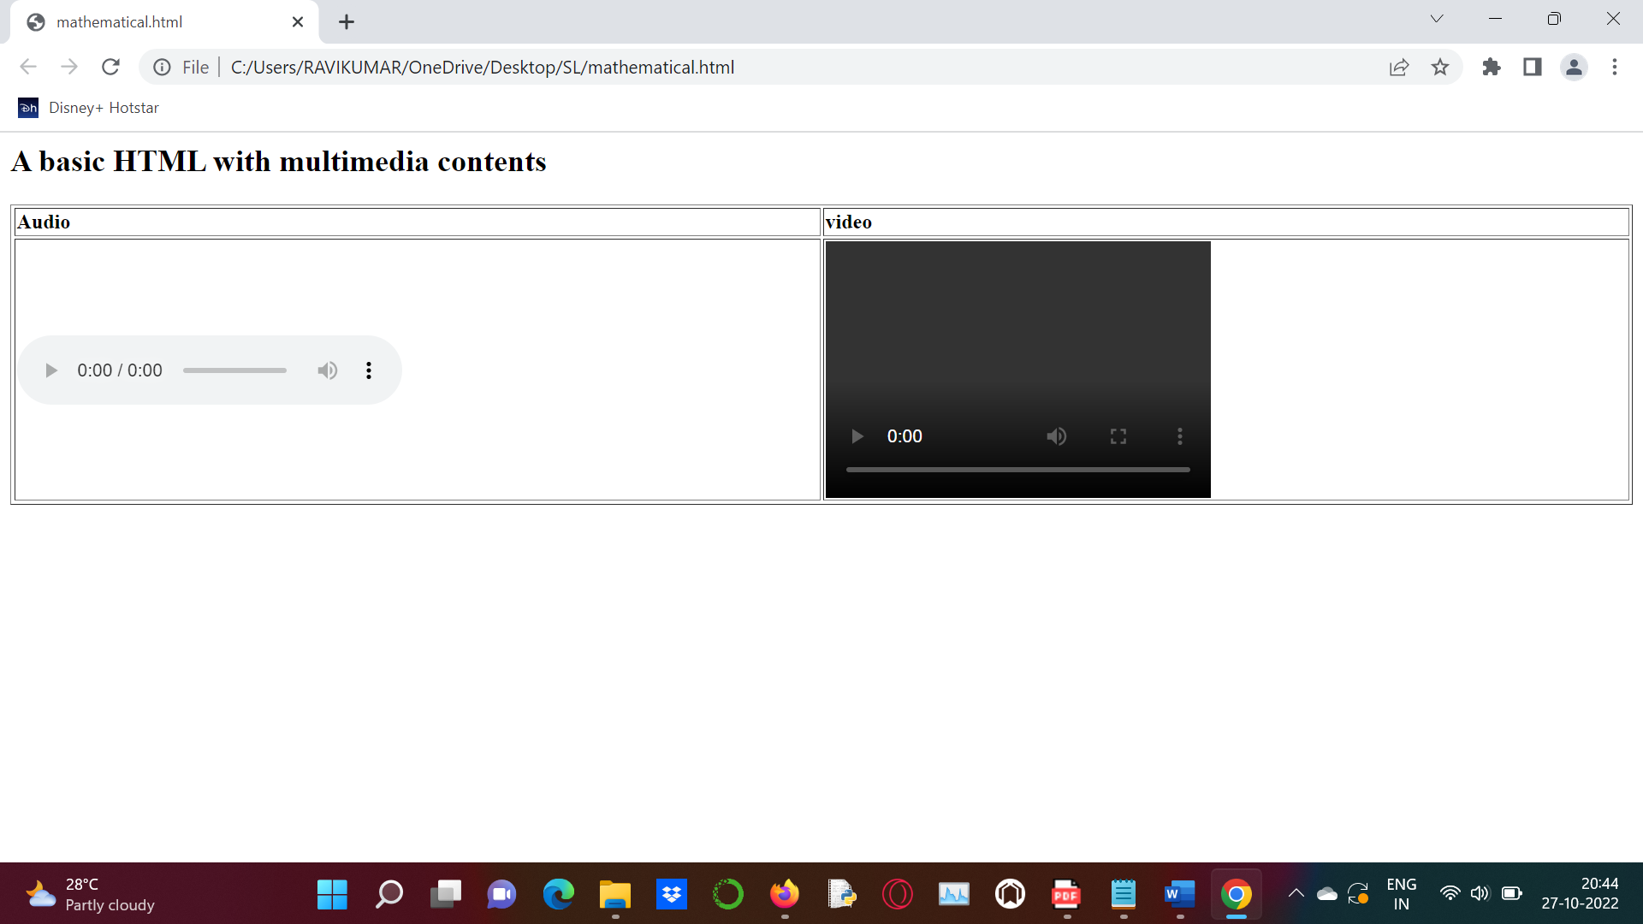

**Program:2**

<html>

<head>

<link rel="stylesheet" href="style.css">

</head>

<body>

<article class="browser">

<h1>Mozilla Firefox</h1>

<p>Mozilla Firefox is an open-source web browser developed by Mozilla. It is the second most popular web browser.</p>

</article>

<article class="browser">

<h2>Microsoft Edge</h2>

<p>Microsoft Edge is a web browser developed by Microsoft. It replaced Internet Explorer.</p>

</article>

<aside>

<p>These are some of the web browsers.But today Google Chrome is a most popular webbrowser</p>

</aside>

</body>

</html>

**Program: (style.css)**

<style>

.browser>h1,

p

{

margin:10px;

font-style:italic;

}

.browser>h2,

p

{

margin:10px;

font-size:150%;

}

.browser

{

background:red;

}

aside

{

width:30%;

padding-left:15px;

margin-left:15px;

float:right;

font-style:italic;

background-color:lightgray;

}

</style>

**Output:**

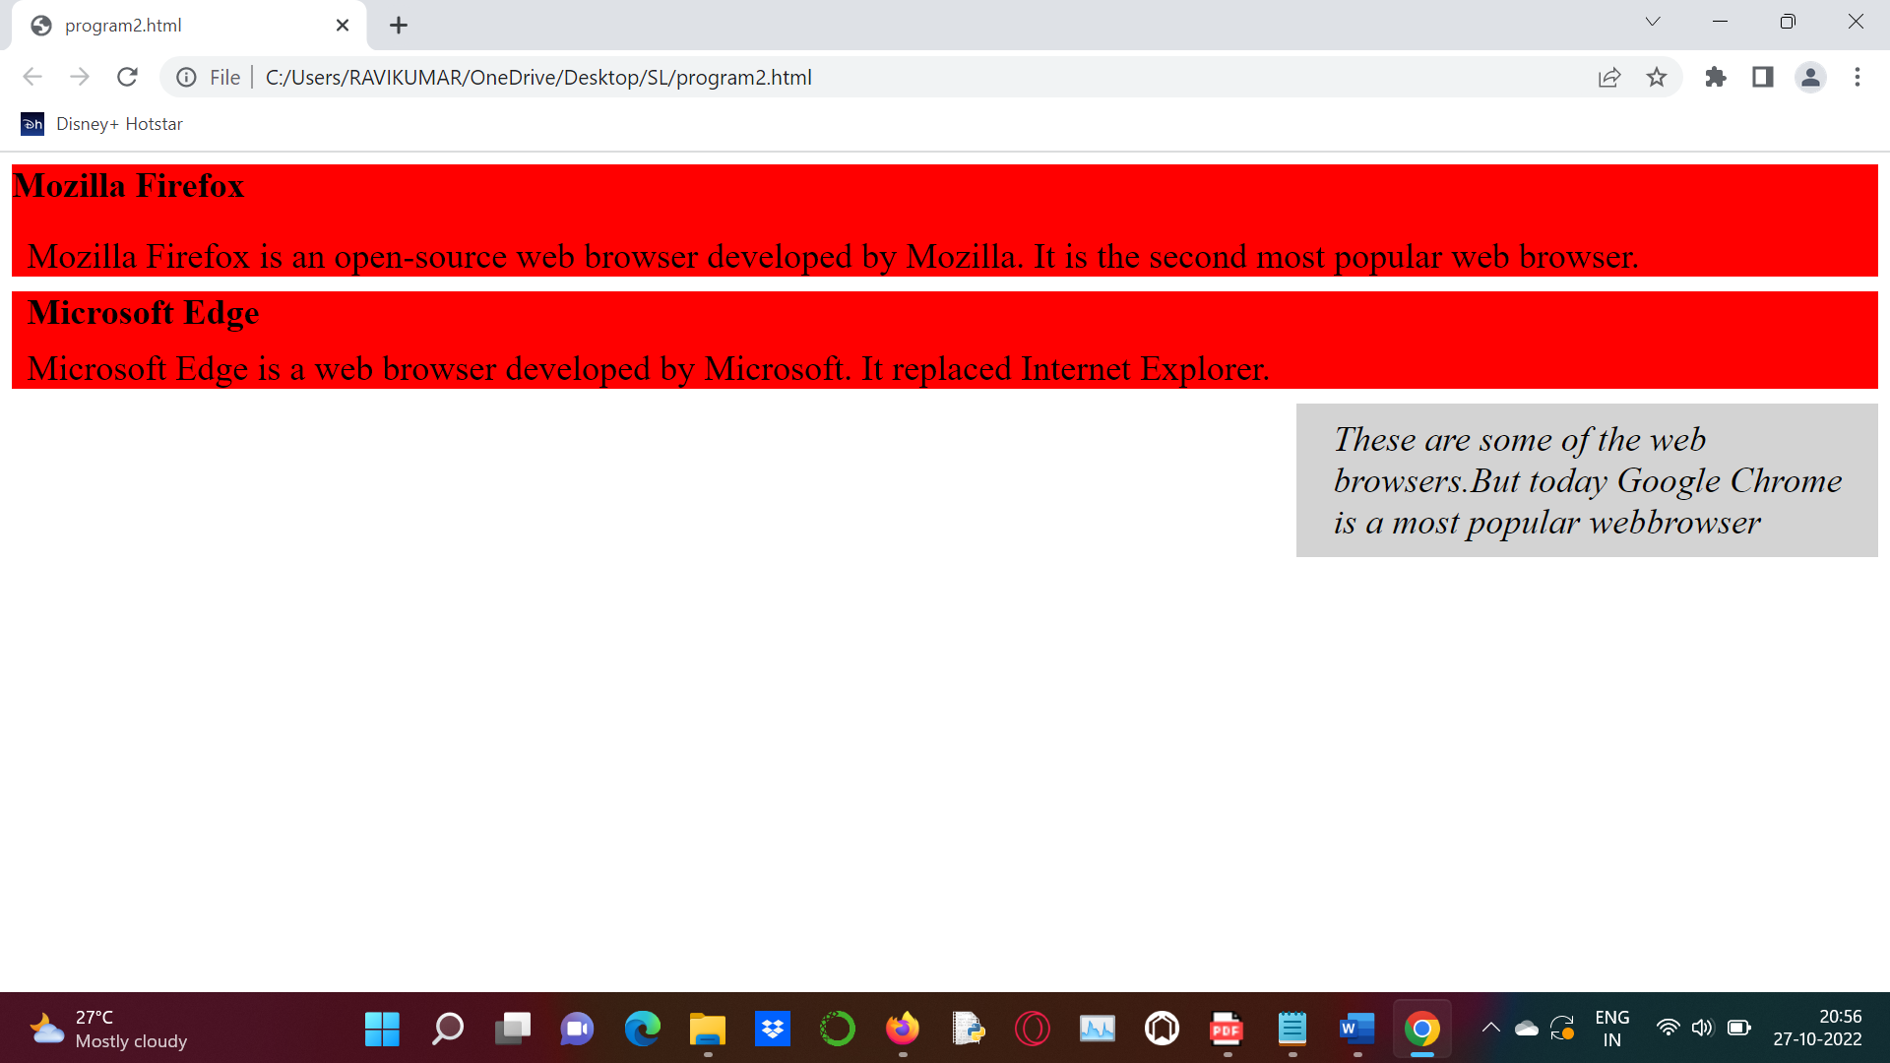

**Program: 3**

<html>

<head>

<title>Mathematical Expression</title>

<script type = "text/javascript">

function math_exp()

{

var x = document.form1.exptext.value;

var result = eval(x);

document.form1.resulttext.value = result;

}

</script>

</head>

<body >

<form name ="form1">

<table>

<tr>

<td>Expression</td>

<td><input type ="text" name ="exptext" /></td>

</tr>

<tr>

<td>Result</td>

<td><input type ="text" name ="resulttext" /></td>

</tr>

<tr>

<td><input type ="button" value ="calculate" onclick ="math_exp()" /></td>

</tr>

</table>

</form>

</body>

</html>

**Output:**

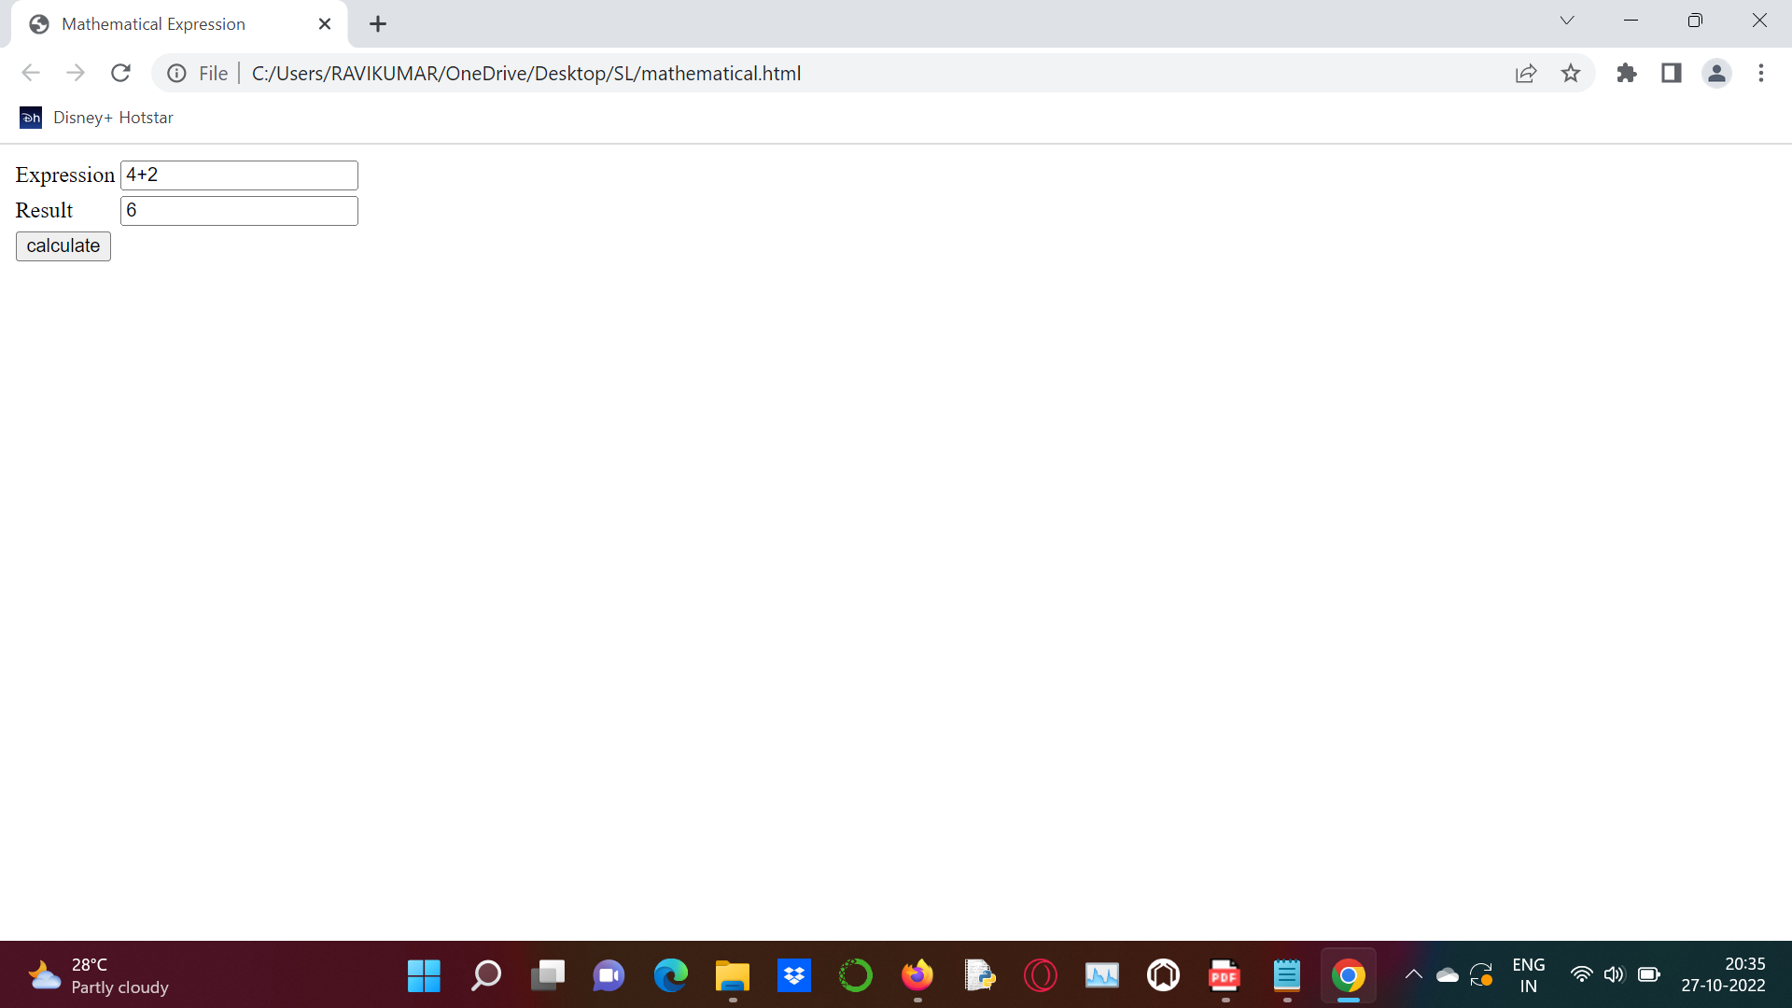

**Program: 4**

<html>

<head>

<title>JavaScript program to find the Sum of n natural numbers</title>

<script type="text/javascript">

function sum()

{

var n,i,sum =0;

n = parseInt(document.getElementById("first").value);

for(i = 1; i <= n; i++)

{

sum =sum+i;

}

document.getElementById("num").innerHTML="Sum of "+n+" natural numbers is :"+sum;

}

</script>

</head>

<body>

<table>

<tr>

<td> <input type="text" name="a" id="first" placeholder="Enter a number"/> </td>

</tr>

<tr>

<td> <button onclick="sum()">Submit</button></td>

</tr>

</table>

<div id="num"></div>

</body>

</html>

**Output:**

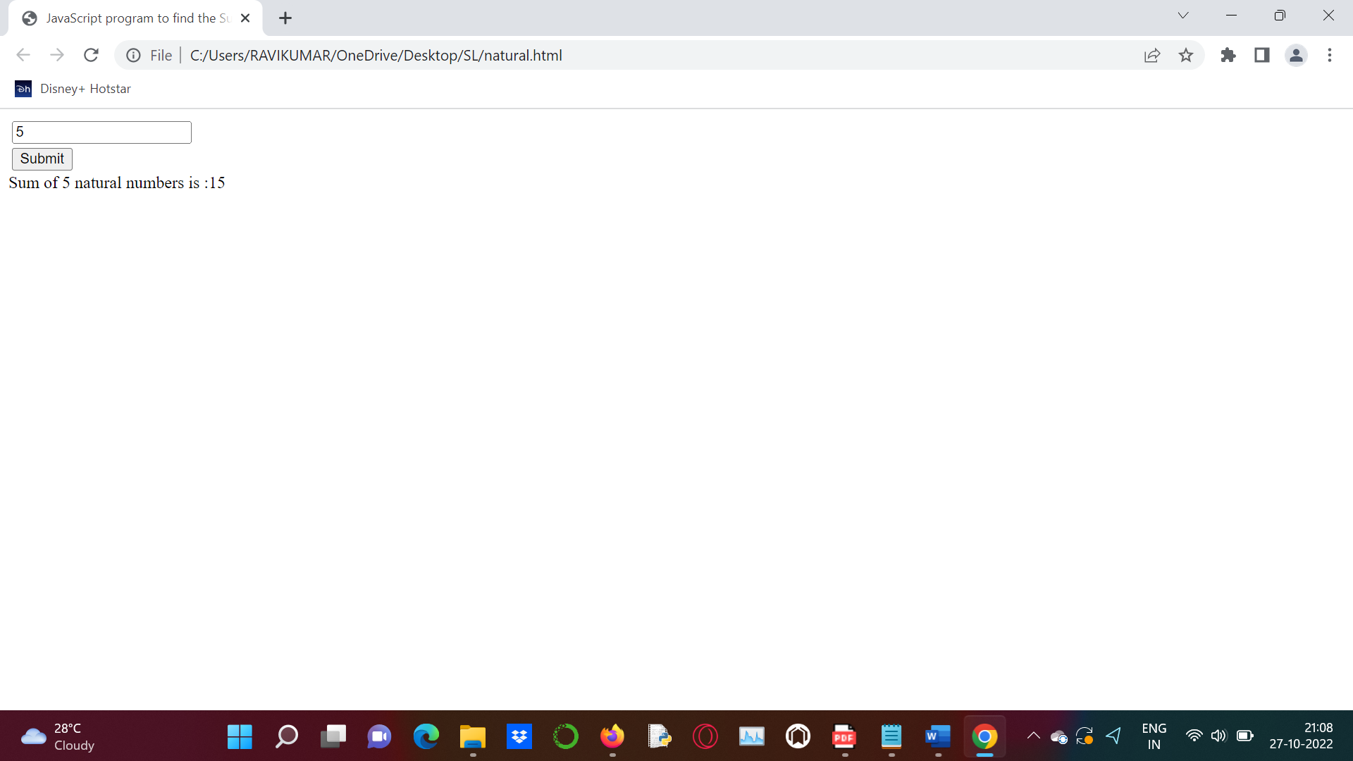

**Program: 5**

<!DOCTYPE html>

<html>

<body>

<img onmouseover="bigImg(this)" onmouseout="normalImg(this)" border="0" src="C:\Users\RAVIKUMAR\OneDrive\Pictures\MEmu Photo\smiley.jpg" alt="Smiley" width="32" height="32">

<p>The function bigImg() is triggered when the user mouse over the image. This function enlarges the image.</p>

<p>The function normalImg() is triggered when the mouse pointer is moved out of the image. That function sets the height and width of the image back to normal.</p>

<script>

function bigImg(x)

{

x.style.height = "64px";

x.style.width = "64px";

}

function normalImg(x)

{

x.style.height = "32px";

x.style.width = "32px";

}

</script>

</body>

</html>

**Output:**

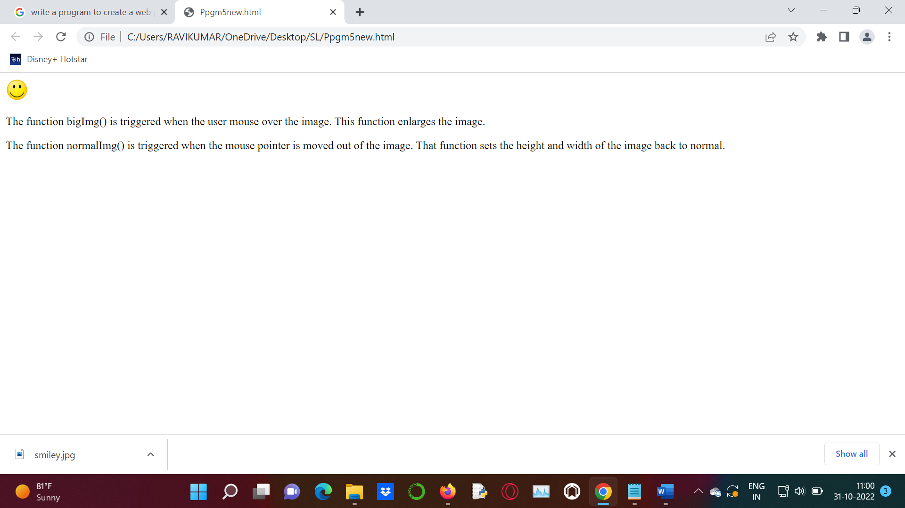

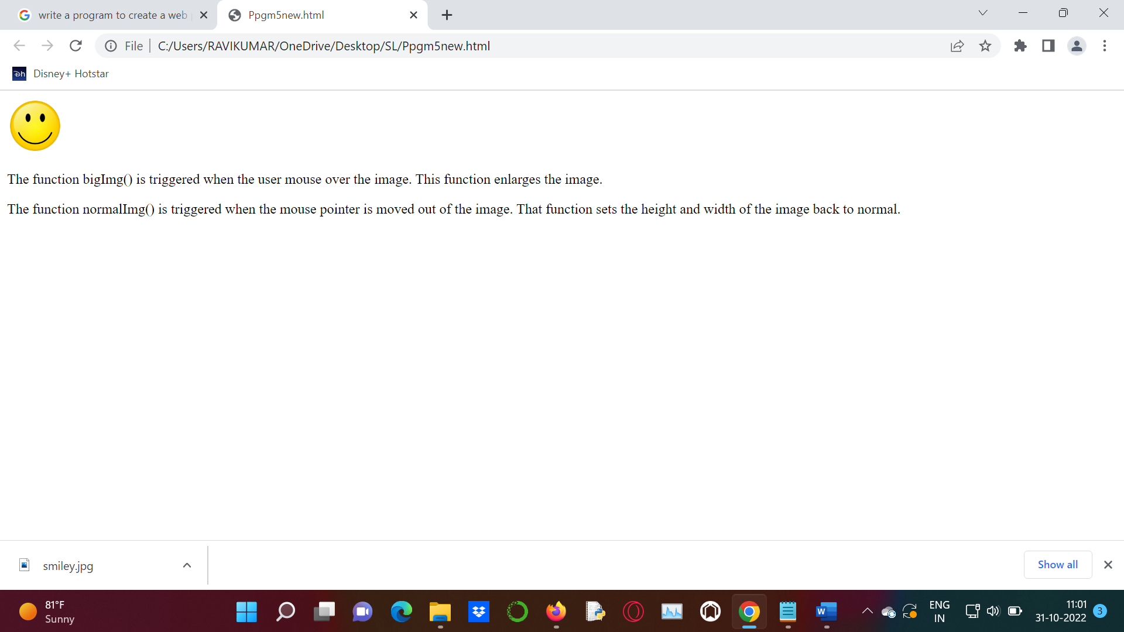

**Program: 6**

<html>

<head>

<title>Registration Form</title>

<script type = "text/javascript">

function display()

{

alert(document.getElementById("form1").length);

}

</script>

</head>

<body onload = "display()">

<form id = "form1">

<table border = "1">

<tr>

<td>Name</td>

<td><input type = "text" value = "firstname" /></td>

</tr>

<tr>

<td>Choose Your Username</td>

<td><input type = "text" value = "Username" /></td>

</tr>

<tr>

<td>Create Password</td>

<td><input type = "password" value = "password" /></td>

</tr>

<tr>

<td>Confirm Password</td>

<td><input type = "password" value = "confirmPass"></td>

</tr>

<tr>

<td>Birthday</td>

<td><select name = "date"><option value = "7" >11</td>

<td><select name = "month"><option value = "November">November</td>

<td><select name = "year"><option value = "1991">1991</td>

</tr>

<tr>

<td>Gender</td>

<td><input type = "radio" name = "gender"/>Male</td>

<td><input type = "radio" name = "gender"/>Female</td>

</tr>

<tr>

<td>Mobile</td>

<td><input type = "text" ></td>

</tr>

<tr>

<td>Location</td>

<td><input type = "text"></td>

</tr>

<tr>

<td><input type = "checkbox" /> I agree the terms and policy</td>

</tr>

<tr>

<td colspan = "2" align = "center"><input type = "submit" value = "Submit" /></td>

</tr>

</table>

</form>

</body>

</html>

**Output:**

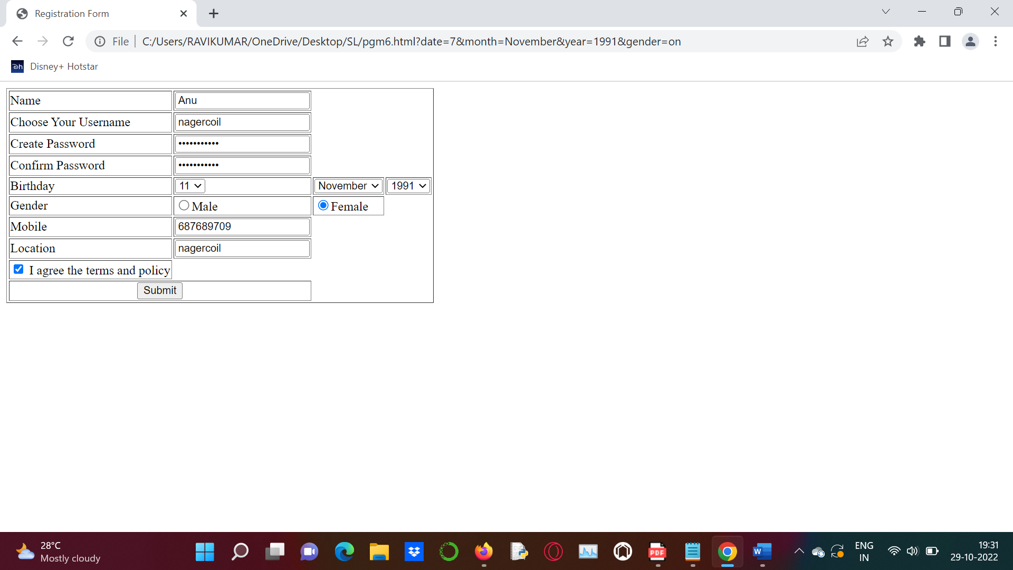

**Program:7**

<html>

<head>

<title>Registration Form</title>

<script type = "text/javascript">

function validate()

{

if(document.myForm.Name.value == "")

{

alert("Please Provide Your Name");

document.myForm.Name.focus();

return false;

}

if(document.myForm.Email.value == "")

{

alert("Please Provide Your Email ID");

document.myForm.Email.focus();

return false;

}

if ((document.myForm.Zip.value == "")||(document.myForm.Zip.value.length != 5))

{

alert("Please Provide a valid zip code format #####");

document.myForm.Zip.focus();

return false;

}

if(document.myForm.Country.value == "-1")

{

alert("Please Provide Your Country Name");

return false;

}

return true;

}

function validateEmail()

{

var emailID = document.myForm.Email.value;

atpos = emailID.indexOf("@");

dotpos = emailID.lastIndexOf(".");

if(atpos < 1 || (dotpos - atpos < 2))

{

alert("Please Enter Correct Email ID");

document.myForm.Email.focus();

return false;

}

return true;

}

</script>

</head>

<body >

<form name = "myForm" onsubmit = "return(validate());" >

<table cellspacing = "2" cellpadding = "2" border = "1">

<tr>

<td>Name</td>

<td><input type = "text" name = "Name" /></td>

</tr>

<tr>

<td>Email ID</td>

<td><input type = "text" name = "Email" onchange = "validateEmail();"/></td>

</tr>

<tr>

<td>Zip Code</td>

<td><input type = "text" name = "Zip" /></td>

</tr>

<tr>

<td>Country</td>

<td><select name = "Country" >

<option value = "-1" selected> [Choose Yours]</option>

<option value = "1" >INDIA</option>

<option value = "2" >USA</option>

<option value = "3" >Srilanka</option>

</select>

</td>

</tr>

<tr>

<td colspan = "2" align = "center"><input type = "submit" value = "Submit" /></td>

</tr>

</table>

</form>

</body>

</html>

**Output:**

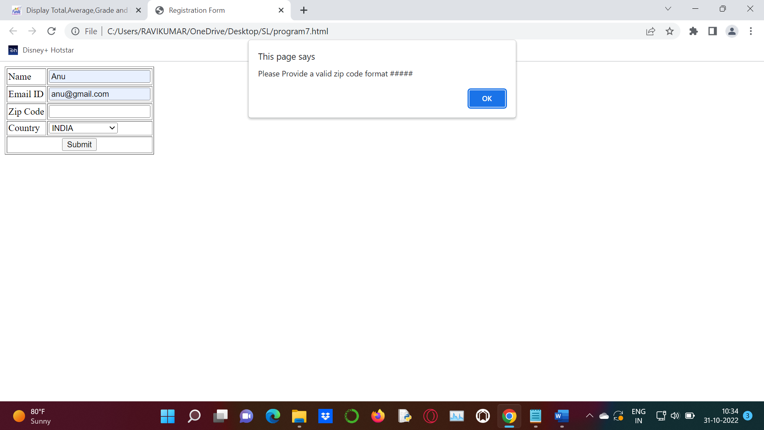

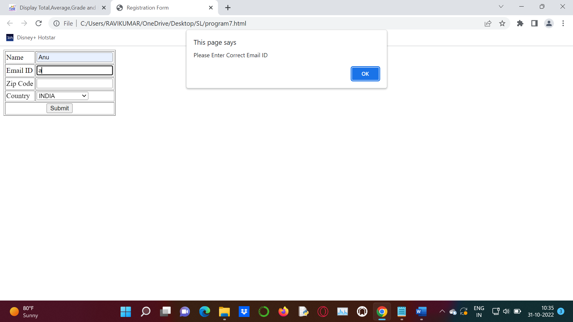

**Program: 8**

<html>

<head>

<title>Student Results</title>

<script type="text/javascript"">

function getReport()

{

var grade = "";

var result="";

var engMarks=document.getElementById('txtEnglish').value;

var tamilMarks=document.getElementById('txtTamil').value;

var mathsMarks=document.getElementById('txtMaths').value;

var scienceMarks=document.getElementById('txtScience').value;

var totalMarks=engMarks-(-tamilMarks)-(-mathsMarks)-(-scienceMarks);

var averageMarks=totalMarks / 4;

switch(

(averageMarks>60 && averageMarks<= 100) ? 1 :

(averageMarks>50 && averageMarks<60) ? 2 :

(averageMarks>40 && averageMarks<50) ? 3 : 0

)

{

case 1 :grade="A";result="First Class";break;

case 2 :grade="B"; result="Second Class";break;

case 3 :grade="C"; result="Third Class";break;

case 0 :grade="D"; result="Fail";break;

}

document.getElementById('txtStudentName').value=document.getElementById('txtName').value;

document.getElementById('txtStudentClass').value=document.getElementById('txtClass').value;

document.getElementById('txtTotalMarks').value=totalMarks;

document.getElementById('txtAvgMarks').value=averageMarks;

document.getElementById('txtGrade').value=grade;

document.getElementById('txtResult').value=result;

}

</script>

</head>

<body>

<fieldset style="width:600px">

<legend><b>Student Input Section:</b></legend>

Name:<input type="text" id="txtName">

Class:<input type="text" id="txtClass"> <br/><br/>

<table border="1">

<tr><td>English</td><td><input type="text" id="txtEnglish"></td></tr>

<tr><td>Tamil</td><td><input type="text" id="txtTamil"></td></tr>

<tr><td>Maths</td><td><input type="text" id="txtMaths"></td></tr>

<tr><td>Science</td><td><input type="text" id="txtScience"></td></tr>

</table><br/><br/>

<input type="button" value="Get Result" onClick="getReport();">

</fieldset>

<h2>Report Card</h2>

<table border="1">

<tr><td>Name</td><td><input type="text" id="txtStudentName" readonly></td></tr>

<tr><td>Class</td><td><input type="text" id="txtStudentClass" readonly></td></tr>

<tr><td>Total Marks</td><td><input type="text" id="txtTotalMarks" readonly></td></tr>

<tr><td>Average Marks</td><td><input type="text" id="txtAvgMarks" readonly></td></tr>

<tr><td>Grade</td><td><input type="text" id="txtGrade" readonly></td></tr>

<tr><td>Remarks</td><td><input type="text" id="txtResult" readonly></td></tr>

</table>

</body>

</html>

**Output:**

